Entertainment & Media APIs

🎮 What Are Entertainment & Media APIs?
# Source: AI Source: Provided by: [Data Path: Persons Table -> ID Column: 1, Name_En Column: Motasem Essam] -> From: [Chatgpt (GPT‑5 Mini)] on [1/19/2026]
Entertainment & Media APIs are web services that provide access to movies, TV shows, music, games, books, celebrities, and other pop culture data. They let developers build apps that search, stream, recommend, or analyze entertainment content from various platforms and databases.

✅ What Entertainment & Media APIs Can Do
# Source: AI Source: Provided by: [Data Path: Persons Table -> ID Column: 1, Name_En Column: Motasem Essam] -> From: [Chatgpt (GPT‑5 Mini)] on [1/19/2026]
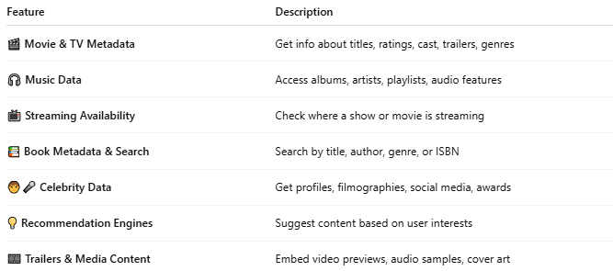

Feature | Description
🎬 Movie & TV Metadata | Get info about titles, ratings, cast, trailers, genres
🎧 Music Data | Access albums, artists, playlists, audio features
📺 Streaming Availability | Check where a show or movie is streaming
📚 Book Metadata & Search | Search by title, author, genre, or ISBN
🧑‍🎤 Celebrity Data | Get profiles, filmographies, social media, awards
💡 Recommendation Engines | Suggest content based on user interests
🎞️ Trailers & Media Content | Embed video previews, audio samples, cover art

🧩 Popular Entertainment & Media APIs
# Source: AI Source: Provided by: [Data Path: Persons Table -> ID Column: 1, Name_En Column: Motasem Essam] -> From: [Chatgpt (GPT‑5 Mini)] on [1/19/2026]
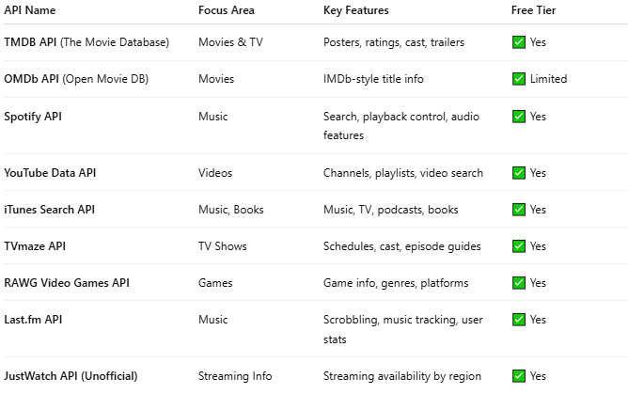

API Name | Focus Area | Key Features | Free Tier
TMDB API (The Movie Database) | Movies & TV | Posters, ratings, cast, trailers | ✅ Yes
OMDb API (Open Movie DB) | Movies | IMDb-style title info | ✅ Limited
Spotify API | Music | Search, playback control, audio features | ✅ Yes
YouTube Data API | Videos | Channels, playlists, video search | ✅ Yes
iTunes Search API | Music, Books | Music, TV, podcasts, books | ✅ Yes
TVmaze API | TV Shows | Schedules, cast, episode guides | ✅ Yes
RAWG Video Games API | Games | Game info, genres, platforms | ✅ Yes
Last.fm API | Music | Scrobbling, music tracking, user stats | ✅ Yes
JustWatch API (Unofficial) | Streaming Info | Streaming availability by region | ✅ Yes

📤 Example: TMDB API (Search Movies)
# Source: AI Source: Provided by: [Data Path: Persons Table -> ID Column: 1, Name_En Column: Motasem Essam] -> From: [Chatgpt (GPT‑5 Mini)] on [1/19/2026]
Request:
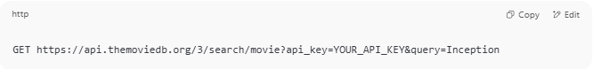
GET https://api.themoviedb.org/3/search/movie?api_key=YOUR_API_KEY&query=Inception

Response:
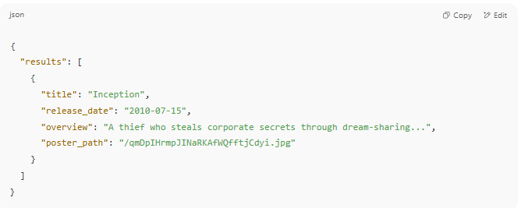
{
"results": [
{
"title": "Inception",
"release_date": "2010-07-15",
"overview": "A thief who steals corporate secrets through dream-sharing...",
"poster_path": "/qmDpIHrmpJINaRKAfWQfftjCdyi.jpg"
}
]
}

🎧 Example: Spotify API (Get Artist Info)
# Source: AI Source: Provided by: [Data Path: Persons Table -> ID Column: 1, Name_En Column: Motasem Essam] -> From: [Chatgpt (GPT‑5 Mini)] on [1/19/2026]
Request:
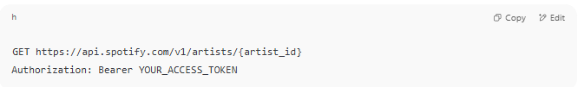
GET https://api.spotify.com/v1/artists/{artist_id}
Authorization: Bearer YOUR_ACCESS_TOKEN

Response:
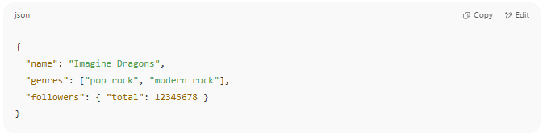
{
"name": "Imagine Dragons",
"genres": ["pop rock", "modern rock"],
"followers": { "total": 12345678 }
}

🧪 Use Cases
# Source: AI Source: Provided by: [Data Path: Persons Table -> ID Column: 1, Name_En Column: Motasem Essam] -> From: [Chatgpt (GPT‑5 Mini)] on [1/19/2026]
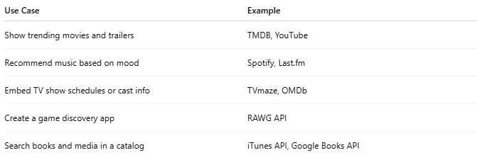

Use Case | Example
Show trending movies and trailers | TMDB, YouTube
Recommend music based on mood | Spotify, Last.fm
Embed TV show schedules or cast info | TVmaze, OMDb
Create a game discovery app | RAWG API
Search books and media in a catalog | iTunes API, Google Books API

🔐 Access & Limits
# Source: AI Source: Provided by: [Data Path: Persons Table -> ID Column: 1, Name_En Column: Motasem Essam] -> From: [Chatgpt (GPT‑5 Mini)] on [1/19/2026]
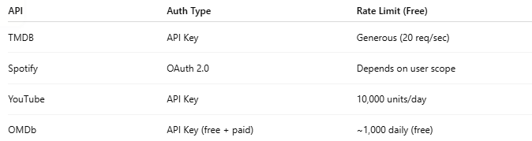

API | Auth Type | Rate Limit (Free)
TMDB | API Key | Generous (20 req/sec)
Spotify | OAuth 2.0 | Depends on user scope
YouTube | API Key | 10,000 units/day
OMDb | API Key (free + paid) | ~1,000 daily (free)

